* **Lab Task 4**

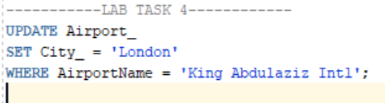Update the Sales department's location to London

OUTPUT: